26.27: a) Since all the external resistors are equal, the current must be symmetrical through them. That is, there can be no current through the resistor R for that would imply an imbalance
in currents through the other resistors.
With no current going through R, the circuit is like that shown below at right.

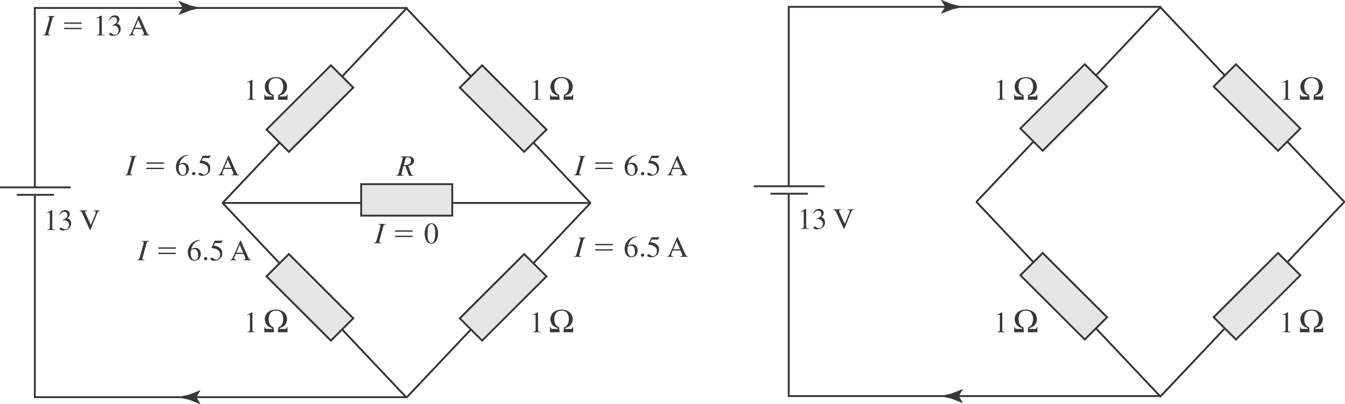

So the equivalent resistance of the circuit is
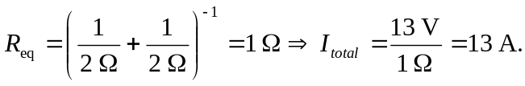
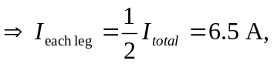 and no current passes through R.
b) As worked out above, 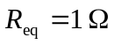.
c) 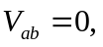 since no current flows.
d) R does not show up since no current flows through it.

